Manual

Add Camera2Dfilters component to the camera. Choose the same pixel density you want to use in your sprites. Choose the vertical resolution. Chose desired filter, and play.

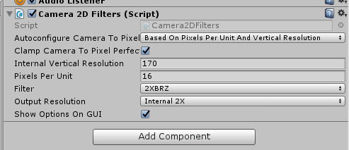

Note that the density chosen in the component is the same density chosen in the sprite. Note also that we use filter mode point to prevent the sprite from being interpolated before the camera filter.

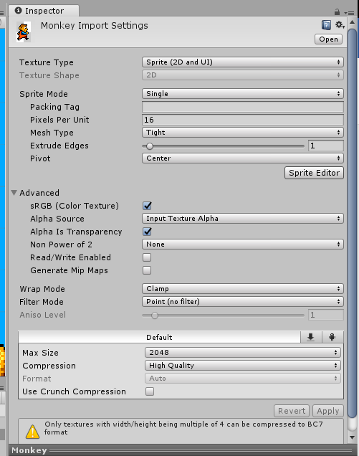

Use the script ClampToPixelPerfectPosition if you need to align each object in the pixel grid.

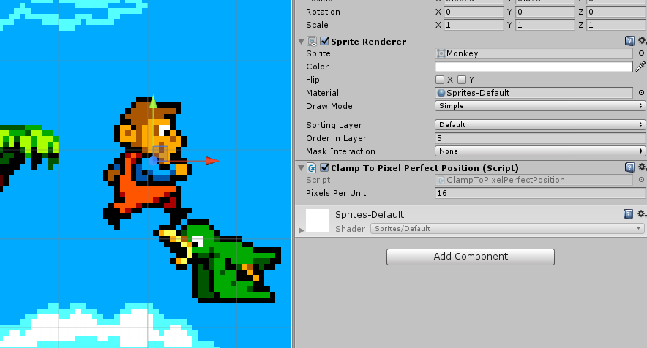

If you want the filter to affect the UI, choose the following settings:

